ACOSA — Final User Journey & Creative Direction Blueprint
Development handover | Luke and Justin | Final pre-launch visual refinement
Creative objective: Transform ACOSA from a functional accommodation website into a polished, premium-feeling business hospitality platform that visually communicates the value of curation and directs visitors toward meaningful action.
Scope: Existing eight page types, global design system, two primary user journeys and a supporting corporate-booker journey.
Non-negotiable: This is a directed visual refinement, not a new website build. Preserve approved copy, functionality, commercial terms and page architecture unless a specific usability problem requires adjustment.
1. The experience we are designing
ACOSA is not competing to appear like the largest accommodation directory. Its differentiation is carefully selected, business-appropriate independent accommodation, supported by practical hospitality experience.
The visual experience must make three promises credible:
- For accommodation seekers: Finding a suitable business stay should feel straightforward, reassuring and relevant.
- For guesthouse owners: Listing with ACOSA should feel like joining a selective commercial network with a clear purpose, not purchasing space in a generic directory.
- For corporate bookers: ACOSA should appear organised, approachable and capable of helping them narrow accommodation options without adding unnecessary complexity.
The website must move from aspiration to evidence to action. Beautiful photography creates interest, but useful information, credible curation and clear conversion routes must finish the job.
Visual reference: the intended character
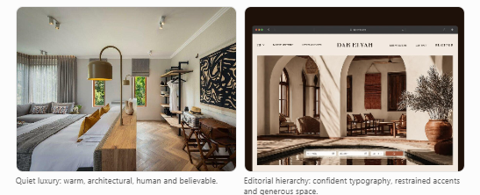
These are mood references, not replacements for the approved ACOSA photography.
2. Global creative system
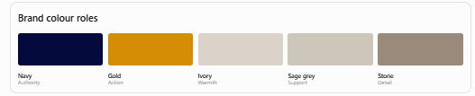
Colour hierarchy: Navy establishes authority; warm light surfaces provide breathing room; gold is reserved for intentional action and selective highlights. Gold should not appear so frequently that everything competes for attention.
Typography: Montserrat for headings and Poppins for body text. Use a consistent hierarchy of eyebrow, H1, H2, H3, supporting text and CTA labels. Headlines should dominate through scale and whitespace, not decorative effects.
Buttons: One restrained rounded-rectangle geometry throughout, approximately 6–8px radius. Primary actions use gold with accessible dark text; secondary actions use an outline or restrained contrasting treatment; tertiary actions are text links. Define accessible hover, focus and disabled states. Never mix pills, squares and heavily rounded buttons.
Arrows and icons: Use one consistent SVG icon family and stroke weight. No skewed arrows, mismatched symbols or decorative speech bubbles. Communication icons should identify genuine contact actions, not serve as general embellishment.
Cards: Use them for discrete items such as properties, nodes, prices and contact routes. Editorial content should rely on typography and space rather than being boxed unnecessarily.
Photography: Preserve the approved image sequence and subject placement. Use the tablet and mobile crops being supplied, rather than allowing CSS to cut off faces, guesthouse features or meaningful business-travel context.
Responsive principle: Mobile must be deliberately composed, not simply compressed desktop. Maintain a clear heading, one dominant action and readable supporting content within each important section.
Premium design test: Remove the ACOSA logo mentally. The typography, buttons, icons, image treatment and spacing should still make every page recognisably part of the same brand.
3. Page-by-page creative direction
Page 01 — Home
Primary entry point
Purpose: Establish ACOSA's proposition within seconds, then direct accommodation seekers and property owners into their respective journeys.
Desired visitor response: “This is relevant to me, it looks credible, and I know where to go.”
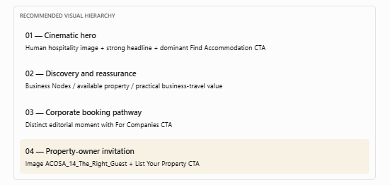
Creative instructions for Luke: The hero must feel like a premium hospitality arrival, not a generic search portal. The headline should remain the dominant focal point, supported by the photograph rather than competing with it. Give the accommodation discovery action a clear visual priority.
The property-owner section must feel like a deliberate transition to a new audience. Use a clear eyebrow, a meaningful shift in composition and the approved welcoming-host photograph. Avoid presenting the owner invitation as just another ordinary content card.
Primary CTA: Find Accommodation → Business Nodes.
Secondary audience CTA: List Your Property → For Properties.
Acceptance: A first-time visitor can identify ACOSA's purpose and their relevant route without scrolling through the entire page. Both audiences have clear entry points, but they do not compete equally in the hero.
Page 02 — Business Nodes
Purpose: Convert the question “Where do I need accommodation?” into a location-based discovery action.
Desired response: “I can quickly identify the business area that suits my trip.”
Visual focal point: The Gauteng node map and seven business-node choices.
Creative instructions: The map must be the central functional feature, not a decorative object below a large block of text. Its visual relationship with the node list must be obvious: selecting a node leads to accommodation in that area.
Create a deliberate hierarchy: page heading → short orientation → map and node selection → accommodation discovery → assistance if nothing suitable is found.
Use consistent markers, clear selected/hover states and concise node labels. On mobile, ensure the node list provides a straightforward alternative to interacting with a small map. Do not allow the map to consume several screens before the visitor can act.
Primary CTA: Select a business node → relevant node page.
Fallback CTA: Ask ACOSA if the required area is not represented.
Acceptance: Visitors can recognise, choose and enter a business node without guessing whether the map or labels are interactive.
Page 03 — Properties
Purpose: Help accommodation seekers identify and evaluate relevant listings efficiently.
Desired response: “I can find suitable options and see why they're appropriate for business travel.”
Visual focal point: Search/filter controls and genuine property cards.
Creative instructions: Make the search controls cohesive rather than visually competing fields and buttons. Present property imagery at a consistent aspect ratio. Within each card, prioritise the property name, location, business-relevant features and a clear View Property action.
The Wild Olive Guesthouse should feel like a high-quality real listing, not a placeholder in an empty directory.
Do not invent additional listings to fill space. A thoughtful limited-inventory presentation is more credible than an artificial catalogue.
Primary CTA: View Property → individual property profile.
Acceptance: A visitor searching for Centurion can identify The Wild Olive Guesthouse and open its profile. Filters and cards remain usable on mobile.
Page 04 — Individual Property Profile
Purpose: Convert property interest into confidence and a direct enquiry.
Desired response: “This property meets my practical requirements, and I know how to contact it.”
Visual hierarchy:
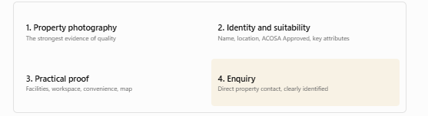
Creative instructions: Treat this page more like a premium property presentation than a technical database record. The gallery should feel generous and intentional. Key business features must be scannable without overpowering the imagery.
The direct-enquiry section should be visually prominent after the visitor has enough information to decide. Distinguish contacting the property from contacting ACOSA.
Do not use an unexplained numerical approval score. Retain ACOSA Approved unless a public scoring model has been explicitly approved.
Primary CTA: Enquire directly with the property.
Acceptance: Visitors can understand the property's location, suitability and contact options without searching through dense information. WhatsApp must address the property correctly.
Page 05 — Why ACOSA?
Purpose: Turn the abstract promise of curation into credible evidence.
Desired response: “ACOSA has a considered approach to choosing accommodation.”
Visual focal point: Hospitality expertise and the selection process.
Creative instructions: This should be ACOSA's most editorial trust page. Use imagery showing thoughtful hospitality and practical assessment rather than decorative luxury alone.
Give the experience claim, selection criteria and ACOSA Approved explanation distinct visual weight. Avoid presenting every criterion as an equally large card. Use a restrained icon grid or well-structured editorial layout where helpful.
The page should communicate judgement, discernment and credibility without implying an external certification or guaranteeing quality beyond what ACOSA can substantiate.
Primary CTA: Explore ACOSA Properties.
Acceptance: A visitor understands why ACOSA's curation adds value and what ACOSA Approved signifies.
Page 06 — For Companies
Purpose: Convince corporate bookers that ACOSA can help them identify suitable accommodation for employees and teams.
Desired response: “This service understands the practical work involved in placing people.”
Visual focal point: Corporate booker needs and the simplicity of the enquiry process.
Creative instructions: Use a more structured, confident B2B visual rhythm than the general seeker pages. The approved corporate-booker and project-team imagery should communicate real professional contexts.
Make the difference between self-service discovery and assisted enquiries immediately apparent. The Teams & Project Stays section should communicate relevance through practical requirements, not generic corporate stock imagery.
The closing contact panel must be clean and decisive. No crowded collection of equally weighted buttons.
Primary CTA: Email Your Requirements.
Secondary CTA: Find Accommodation where appropriate; WhatsApp ACOSA as the lower-priority contact alternative.
Acceptance: An office manager or project coordinator can identify the information to send and reach the appropriate enquiry channel with minimal effort.
Page 07 — For Properties
Highest visual-priority page
Purpose: Persuade qualified accommodation providers that ACOSA offers worthwhile, focused visibility and make the listing application feel like a considered commercial decision.
Desired response: “This network is relevant to my property, the value is clear, and I understand what happens next.”
This page requires the strongest visual choreography because it must accomplish several different jobs without becoming fragmented.
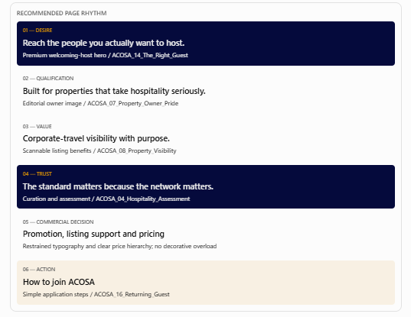
Creative instructions: Do not treat these six stages as interchangeable content sections. Each must have a distinct purpose and visual intensity.
The hero sells the opportunity. Qualification introduces selectivity. Benefits demonstrate value. Curation justifies trust. Pricing enables the decision. The application section removes uncertainty.
Use fewer decorative containers and stronger typographic contrast. Pricing should be immediately readable, with the R389 partner rate clearly identified as the partner offer without hiding the R499 standard or R4,290 annual options.
The final application area should feel like a conclusion, not another competing promotional panel. Avoid stacked duplicate application CTAs.
Primary CTA: Start Your Application.
Supporting CTA: See What's Included, particularly near the hero.
Acceptance: A property owner can explain who ACOSA accepts, what a listing includes, what it costs and how to apply after one natural scroll through the page. The visual pacing should feel intentional on desktop, tablet and mobile.
Page 08 — Contact
Purpose: Route different enquiries to the correct destination with minimal confusion.
Desired response: “I know which option applies to me.”
Creative instructions: This page should be the most restrained of all. Use a concise heading, clearly differentiated enquiry types and consistent contact treatments.
Do not introduce another elaborate hero or decorative visual concept. Premium here means effortless navigation.
Primary routes: Accommodation assistance, corporate/team enquiry, property listing application and general enquiry.
Acceptance: Every visitor can identify the appropriate contact option quickly, and each action opens the correct channel with accurate context.
4. Conversion rules across the entire site
The most important design principle for Luke is that not every CTA deserves equal visual prominence.
Visitor situation | Dominant action | Design requirement
Arriving on Home | Find Accommodation | Immediately identifiable
Exploring a business node | View available properties | Map and node choices work together
Reviewing search results | View Property | Clear within each listing
Considering a property | Enquire with property | Prominent, unambiguous contact
Evaluating ACOSA's credibility | Explore Properties | Follows trust-building content
Booking for a team | Email Your Requirements | Strong B2B conversion treatment
Considering a listing | Apply to List | Benefits and pricing lead toward it
Needing assistance | Contact the correct party | Clear distinction between ACOSA and the property
Avoid competing gold buttons within the same visual grouping. If two actions are equally prominent, the visitor must work harder to decide.
5. Responsive image implementation
Your current image resizing is an important part of this brief, not a separate cosmetic exercise.
For each approved image, Luke should receive a desktop, tablet and mobile variant where necessary, together with the intended subject focal point.
Image use | Tablet priority | Mobile priority
Hero | Preserve person and setting | Preserve subject and readable headline space
Editorial split section | Balanced image/text composition | Crop for subject, then stack content
Property cards | Consistent gallery ratio | Consistent crop across all cards
For Properties storytelling | Preserve owner/guest interaction | Keep the human relationship visible
Team accommodation | Preserve relevant group context | Avoid cutting off people awkwardly
Do not use fixed image heights indiscriminately. Different breakpoints may need different container proportions to preserve the intended composition.

